How to create a Json storage in JSONBIN

1. Login to the site using preferred login method which will lead you to following screen:
2. 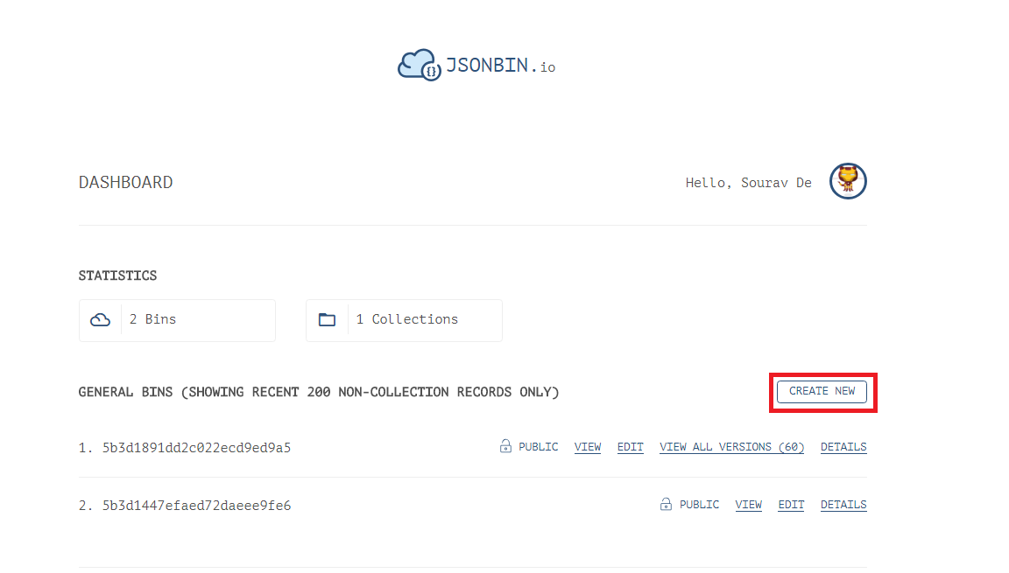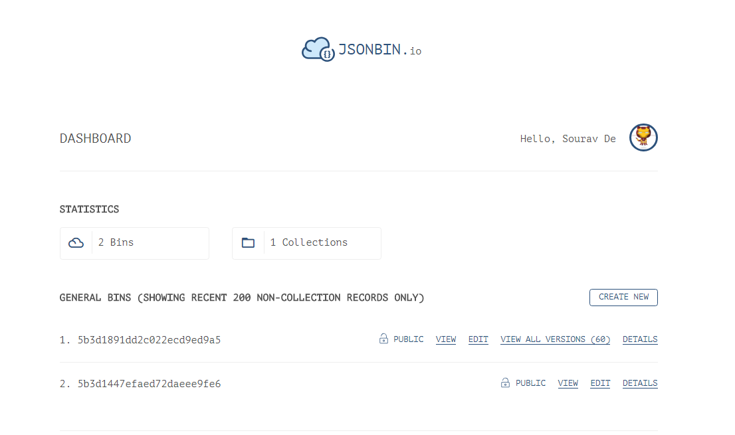Click on “Create New” button
3. 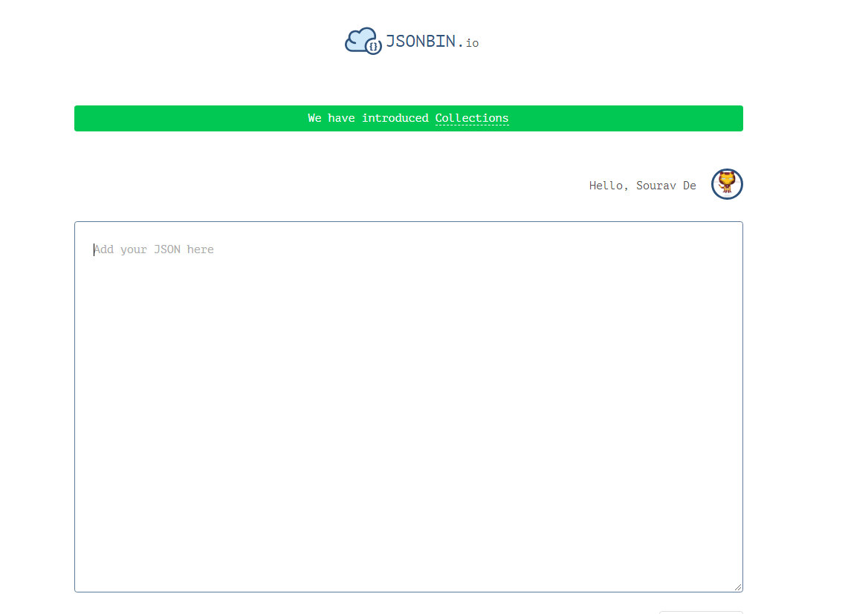Which will go to the following window
4. 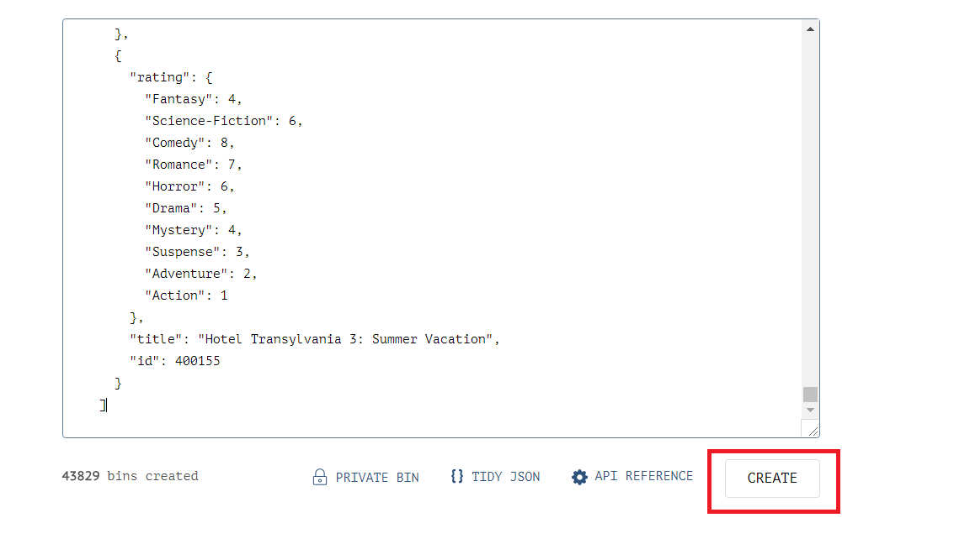Open the datastore.json file and copy the data from there to paste it into the “add your JSON here” field.
5. Click on the create button to create the JSON data store on the site.
6. 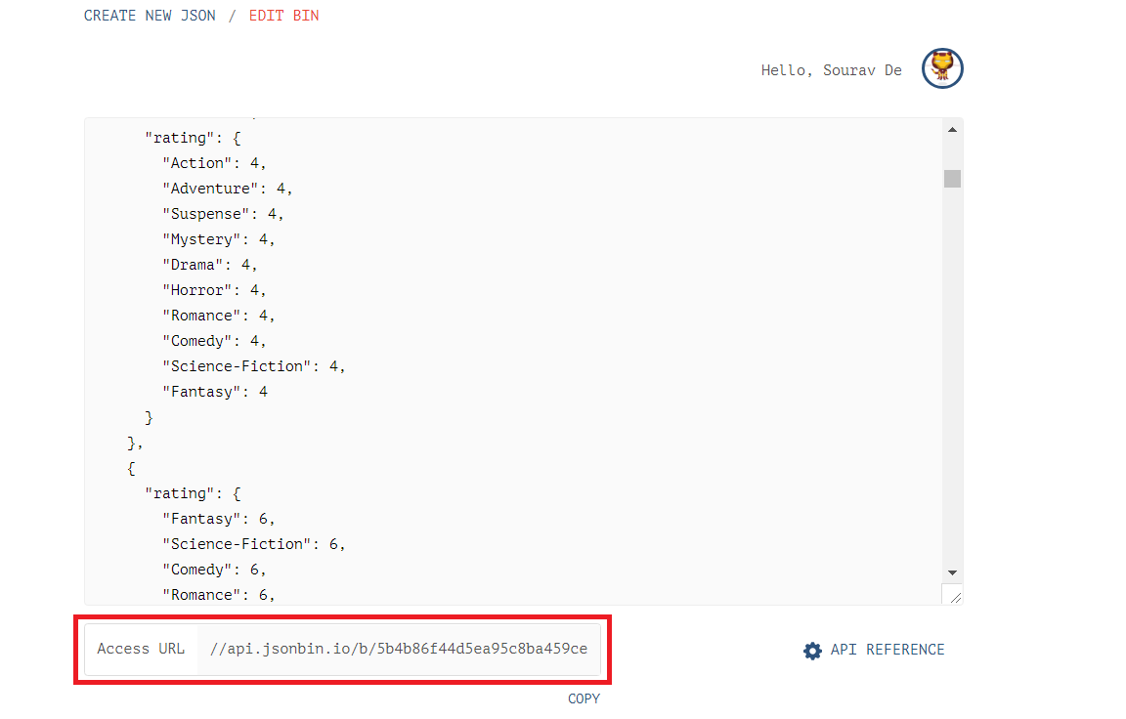After this the following window will appear
7. Please send me the “Access URL” portion so that I can link the site to your account.
8. 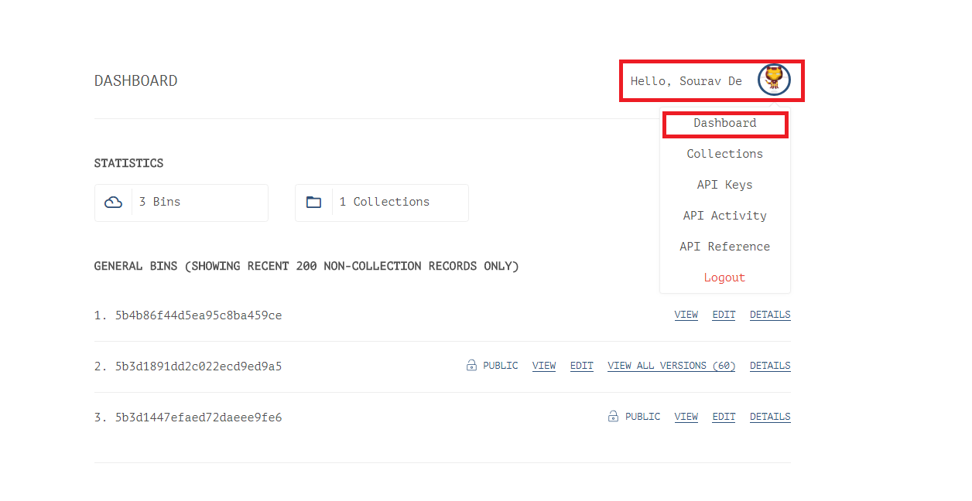To edit to your survey values, click on your account name like following
9. Next click on the edit button

